**TO:** Institute for Research on Poverty (IRP), University of Wisconsin-Madison

**FROM:** Benjamin Poag

**SUBJECT:** Blossoms of Poverty: poverty, substance abuse, and mental illness in the U.S.

**DATE:** April 29, 2022

**Motivation and Research Question**

The United States has witnessed a national spike in poverty over the course of the COVID-19 pandemic, with the 2020 U.S. Census reporting a 11.4% increase in the poverty rate from 2019 after five consecutive annual declines.[1] Alongside this sudden spike in poverty, steady upward trends in both alcohol and substance use suggest a burgeoning public health problem in the U.S. Between 2002 and 2013, there was a 49.4% increase in prevalence of alcohol use disorder (AUD) throughout the U.S., and prescription opioid and heroin overdose rates have more than quadrupled since 1999.[2] [3] Both alcohol and substance use contribute to significant life expectancy gaps between those with substance use disorders and the general population.[4] Prevalence of mental illness is also on a steady upward trajectory. The Global Burden of Disease study identified an 11% increase in poor mental health between 1990 and 2016, suggesting that this growing public health crisis predates the pandemic’s effects.[5]

However, it is pivotal to avoid considering these problems in a siloed manner; research has demonstrated that socioeconomic conditions and these public health issues are intertwined in a mutually reinforcing way. According to a 2017 study, U.S. adults with one mental illness or substance use disorder reported significantly higher rates of living in poverty, receiving government assistance, being unemployed, and having no health insurance.[6] The current study poses the following question: How significant is poverty in explaining AUD mortality rates, SUD mortality rates, and mental distress throughout the U.S.? Moreover, what implications might these results have in public policy? By examining these questions with an explanatory approach, this research may assist the IRP in assessing the correlates of poverty throughout the U.S., and may in turn motivate policies and programs to combat poverty and inequality throughout the country.

**Research Population**

The population of interest for this study is that of current U.S. residents. Since data from individual subjects in the U.S. is scarce and would be extremely difficult to process efficiently, the population data I used have been averaged at the county level. Overall, county-level data aggregated across all states will serve as a representative approximation of the U.S. population, leveraging both the granularity of the county level and its efficiency relative to individual cases. Each county entry represents hundreds to millions of individuals.

**Datasets**

For the current study, I sourced my data from three different organizations. I drew my county-level data on poverty rates from the U.S. Census Bureau 2020 Small Area Income and Poverty Estimates (SAIPE) Program. This program was created to provide more concise and current estimates of poverty, and it maintains strong validity for the purposes of this study by leveraging county-level observations based on responses to the American Community Survey and implementing a regression model to predict poverty rates and adjust for reliability problems due to sample sizes in certain counties.[7]

AUD and SUD mortality rates were drawn from the Institute for Health Metrics and Evaluation. These data are derived from de-identified health records from the National Center of Health Statistics (NCHS), population statistics from the U.S. Census Bureau, NCHS, and the Human Mortality Database, and the cause list from the Global Burden of Disease Study.[8] Small area estimation models were implemented, enabling for finer geographic detail and greater precision in analyzing statistics drawn from smaller subpopulations.[9]

Finally, data on frequent mental distress were pulled from the County Health Rankings & Roadmaps program, specifically from the 2020 County Health Rankings National Data. I chose to use statistics on frequent mental distress rates (percentage of adults reporting 14 or more days of poor mental health per month) instead of diagnosed psychopathology, due to the inequitable distribution of diagnostic resources across the U.S. counties and resulting validity concerns. The Rankings & Roadmaps program implements many tools to ensure the reliability of the data used, including the use of multiple measures for each construct and age-adjustment to increase comparability of health measures across counties.[10]

**Research Design**

For my research design, I implemented an explanatory approach using three observational datasets from national surveys to evaluate the value of poverty in explaining the adverse outcomes under study. I gathered all of the observational datasets and trimmed them down to the relevant observational variables. County entries not common to all datasets were eliminated, but this constituted a miniscule minority of counties (primarily in Alaska) and thus did not impact the validity of the results. Once the data were formatted, I used the usmap and ggplot2 packages in R to fit the county-level values to the U.S. map. Each county was filled according to the county rate reported for each variable. These visualizations can be found below in Figure 1. In these mappings, some counties were not represented in all datasets, and therefore several unfilled spaces are present in the maps.

*Figure 1. U.S. geographical mappings of poverty (A), AUD (B) and SUD (C) mortality, and frequent mental distress (D) rates.*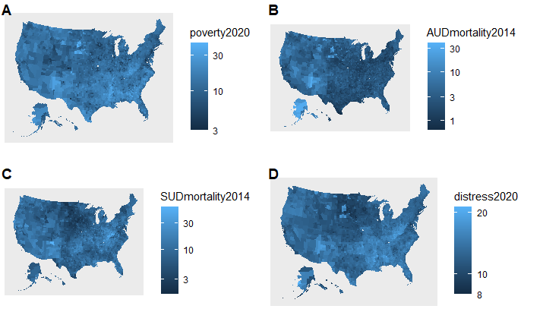

Several initial observations can be made regarding these visualizations that justify an explanatory research design. Notably, poverty is most concentrated in the South, Appalachia, and counties containing Native American reservations (i.e., areas in South Dakota, Arizona, New Mexico, and Alaska). In fact, American Natives and Alaska Natives hold the highest national poverty rates by race, possessing an average of 27.0%.[11] AUD mortality is concentrated in regions occupied by American Natives and Alaska Natives. SUD mortalities can be attributed most to Appalachia, which aligns with the region’s high rates of opioid overdose. Finally, frequent mental distress is distributed prevalently among all aforementioned regions. The extensive geographical overlap among all of these variables across the U.S. offers promising implications for evaluating the explanatory role of poverty in relation to the outcome variables.

**Analytic Technique**

The analytic technique I implemented involved fitting three multiple regression models in R (one for each of the outcome variables) and plotting partial regressions with poverty as the independent variable. This technique enabled for rigorous evaluation and useful visualization of poverty as the central explanatory variable while accounting for confounding variables. All models used the poverty rate of each county as the key explanatory variable. The models assessed AUD mortality rate, SUD mortality rate, and frequent mental distress rate in turn as dependent variables on the county level. I established a level of 𝛼 < .05 as the cutoff for statistical significance, and plotted the partial regression for each to visualize the effect of poverty while controlling for potential confounding variables.

Since there are a number of variables that systematically vary with poverty and could potentially influence the outcomes considered (thus inflating or deflating the effect of poverty), several confounding variables have been incorporated into each model using data from the Rankings & Roadmaps program. Given both poverty and mental illness’s direct relationships with unemployment and having less than a high school education, both unemployment and high school graduation rates have been added.[12] Women and families with only a single source of income are also at higher risk of falling into poverty and developing mental health and substance use problems, providing rationale to include the female split of each county population and the percentage of single-parent households.[13] Moreover, as potential stressors that may drive mental illness and substance use, food insecurity rates and rates of severe problems in housing (defined as having at least one of the following issues: overcrowding, high housing costs, lack of kitchen facilities, or lack of plumbing facilities) have been incorporated.[14]

**Results and Discussion**

The main purpose of the current study is to determine how powerful poverty is as a predictor of these outcomes in the U.S. using county poverty rates (Note: “predictor” refers to an explanatory variable in multiple regression). Each multiple regression analysis incorporates covariates to account for confounders. The first regression was conducted between AUD mortality rate and poverty rate. With covariates accounted for, poverty was not found to be a significant predictor of AUD mortalities at the county level (*p* > .05), even though the model itself moderately fit the data (*adjusted* *R*2 = .25). Statistical results and the AUD partial regression can be found in Table 1 and Figure 2, respectively. The next regression analysis was conducted between the SUD mortality rate and poverty rate. Poverty was discovered to be a significant predictor of SUD mortalities at the county level with confounders factored in, β = 0.291, *p* < .01. However, the model itself accounted for little of the variance in SUD mortality (*adjusted* *R*2 = .14). These statistical results and the SUD partial regression can be found in Table 2 and Figure 3, respectively. The final multiple regression was performed between frequent mental distress rate and poverty rate. Accounting for confounders, poverty was a significant predictor of mental distress on the county level, β = 0.209, *p* < .01. Moreover, the model fit the data quite robustly (*adjusted* *R*2 = .63). These statistical results and the mental distress partial regression can be found in Table 3 and Figure 4, respectively.

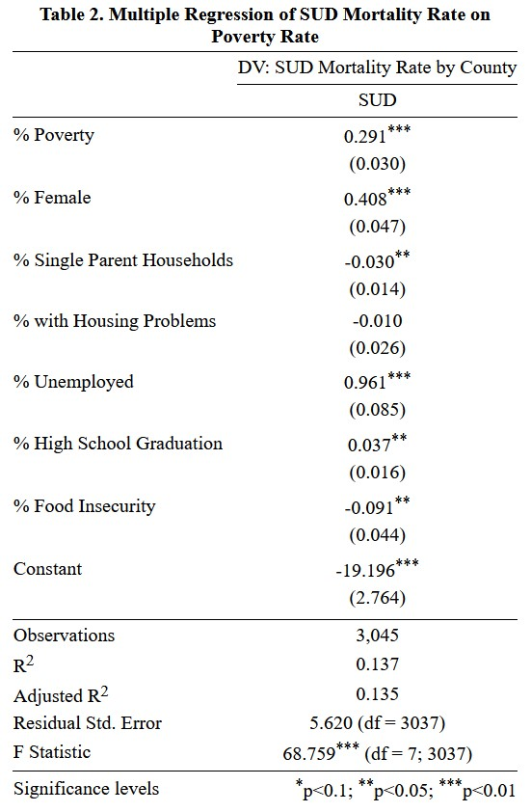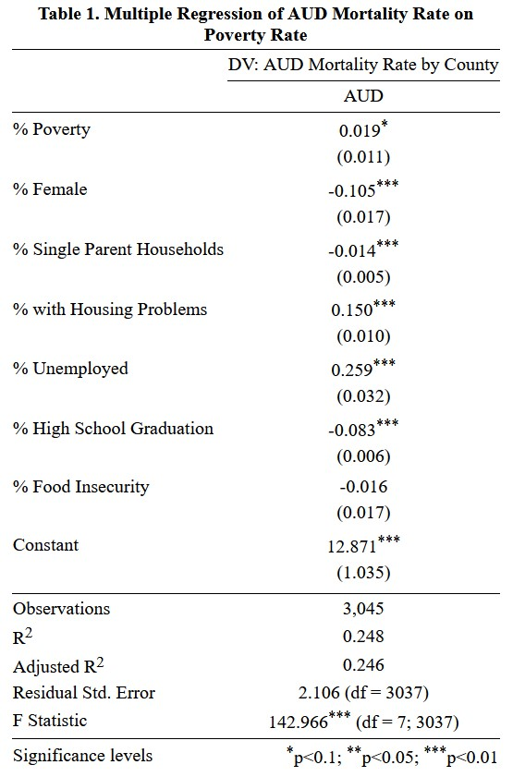

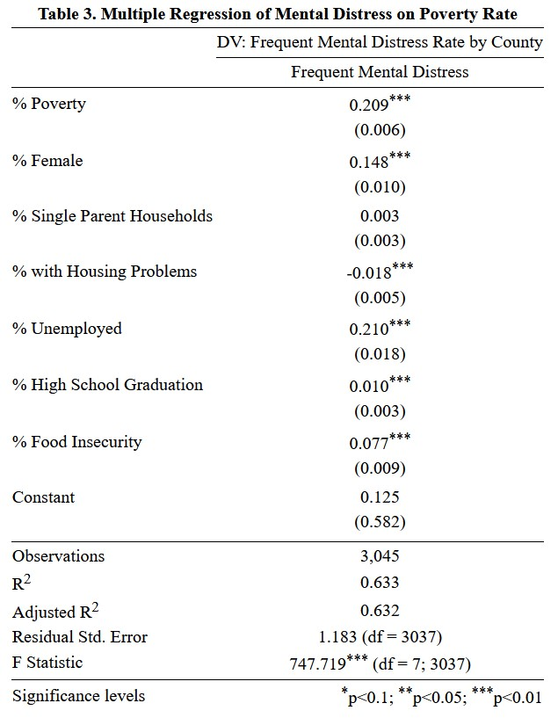

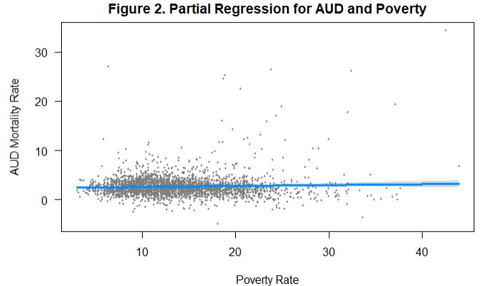

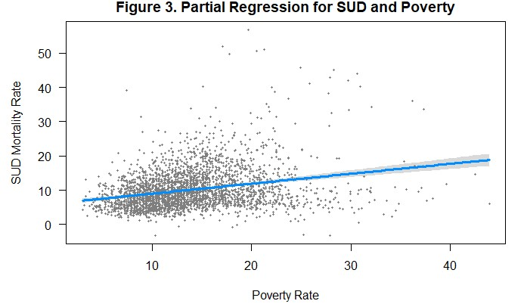

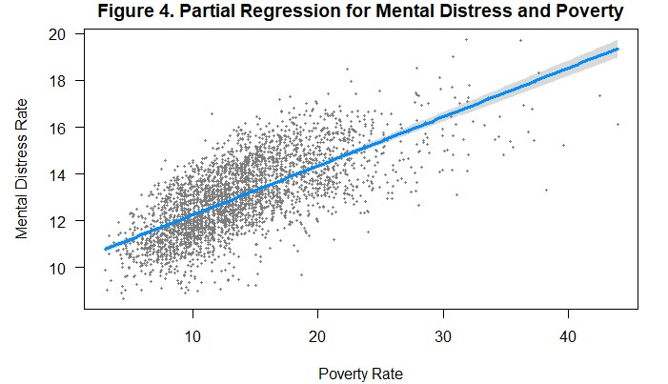

Although the relationship between poverty and AUD mortality was insignificant, the prevalence of poverty and alcohol-related deaths among American Natives and Alaska Natives is undeniable (see Research Design), and is consistent with findings that these ethnic groups are more genetically predisposed to alcohol use-related diseases and may abuse alcohol at higher rates.[15] The positive association between poverty rate and SUD mortality is unsurprising; smoking-attributable mortality, overdose deaths from prescription drugs, as well as alcohol-attributable mortality are directly linked to lower socioeconomic status.[16] However, interpreting these results is highly complex due to the multifaceted nature of poverty. A lack of access to healthcare, low social cohesion among neighbors, and availability of isolated spaces where overdoses can occur could act as mechanisms through which low socioeconomic status can translate into risk for drug-related mortality. External stressors stemming from poverty, including food insecurity, unemployment, and low educational attainment, may also drive misuse of illicit drugs to cope with chronic stress.[17] As a result, the compounding stressors of poverty seem to interact in a cycle that heightens SUD-related mortalities, not just in the U.S., but globally.

Poverty and mental distress, as the results demonstrate, are also linked, even in previous research. For instance, those occupying the lowest socioeconomic bracket possess eight times more risk of developing schizophrenia relative to other income groups.[18] Thus, a powerful relationship exists between poverty and mental illness, one that is perhaps so powerful because the two constructs tend to mutually reinforce one another. In one sense, poverty drives mental distress through increased life event stressors, poor maternal and prenatal care, and limited social resources. However, mental illness may also drive poverty, such that individuals who develop mental disorders drift into poverty by dropping out of school and remaining unemployed.[19]

The geographical mappings and analytic results produced from this research design demonstrate the importance of treating AUD, SUD, and mental illness holistically by starting at the root variable that undeniably links all of them: poverty. Moreover, although AUD mortality was not significantly linked to poverty, there are nonetheless interactions between the two issues among American Native and Alaska Native populations. Thus, the IRP may use this research as a springboard for launching policies that expand social relief services to poverty-stricken regions of the U.S. (i.e., the South, Appalachia, and Native American reservations) and come closer to universalizing mental health and substance abuse treatment resources for these vulnerable individuals. Further research may contribute to the IRP’s efforts and build on the findings and limitations of this study by expanding the covariates of poverty accounted for, drawing from alcohol and substance use data from more recent datasets, and conducting more focused regional analytical approaches to better target policy interventions.

References

Azih, C. A-M. (2018). “Analysis of Factors Contributing to Poverty in the United States: An

Empirical Study.” *Methodist University*. https://www.methodist.edu/wp-content/uploads/2018/09/mr2017_chioma.pdf

Beauvais F. (1998). American Indians and alcohol. *Alcohol health and research world*, *22*(4),

253–259.

Charlson, F., Baxter, A., Dua, T., Degenhardt, L., Whiteford, H., & Vos, T. (2015). Excess

mortality from mental, neurological and substance use disorders in the Global Burden of

Disease Study 2010. *Epidemiology and Psychiatric Sciences,* *24*(2), 121-140. doi:10.1017/S2045796014000687

Coleman-Jensen, A., Helms, V. E., & Mentzer Morrison, R. (2020). Food Insecurity Rates Are

Relatively High for Participants in Housing and Urban Development (HUD) Assistance

Programs. *Amber Waves: The Economics of Food, Farming, Natural Resources, and*

*Rural America*, *2020*(1490-2020-1750).

County Health Rankings & Roadmaps. (2022). *Data Quality*. Retrieved from

https://www.countyhealthrankings.org/explore-health-rankings/our-methods/data-quality

Grant, B., Chou, S. P., Saha, T. D., Pickering, R. P., Kerridge, B. T., Ruan, J., ...Hasin, D. S.

(2017). Prevalence of 12-month alcohol use, high-risk drinking, and DSM-IV alcohol use

disorder in the United States, 2001-2002 to 2012-2013. *JAMA Psychiatry, 74*, 911-923.

Holzer, C. E., Shea, B. M., Swanson, J. W., & Leaf, P. J. (1986). The increased risk for specific

psychiatric disorders among persons of low socioeconomic status. *American Journal of*

*Social Psychiatry*.

Institute for Health Metrics and Evaluation. (2014). *US Data*. Retrieved from

https://ghdx.healthdata.org/us-data

Pear, V. A., Ponicki, W. R., Gaidus, A., Keyes, K. M., Martins, S. S., Fink, D. S., Rivera-Aguirre,

A., Gruenewald, P. J., & Cerdá, M. (2019). Urban-rural variation in the socioeconomic

determinants of opioid overdose. *Drug and alcohol dependence*, *195*, 66–73.

https://doi.org/10.1016/j.drugalcdep.2018.11.024

Radfar, A., Ferreira, M. M., Sosa, J. P., & Filip, I. (2021). Emergent Crisis of COVID-19

Pandemic: Mental Health Challenges and Opportunities. *Frontiers in psychiatry*, *12*,

631008. https://doi.org/10.3389/fpsyt.2021.631008

Rehm, J., & Probst, C. (2018). Decreases of life expectancy despite decreases in

non-communicable disease mortality: the role of substance use and socioeconomic status.

*European addiction research*, *24*(2), 53-59.

Saraceno, B., & Barbui, C. (1997). Poverty and mental illness. *The Canadian Journal of*

*Psychiatry*, *42*(3), 285-290.

U.S. Census Bureau. (2020, September 14). *Income and Poverty in the United States: 2020*.

Retrieved from https://www.census.gov/library/publications/2021/demo/p60-273.html

U.S. Census Bureau. (2011). *Poverty Rates for Selected Detailed Race and Hispanic Groups by*

*State and Place: 2007-2011*. Retrieved from

https://www.census.gov/library/publications/2013/acs/acsbr11-17.html

U.S. Census Bureau. (2020). *Small Area Estimation*. Retrieved from

https://www.census.gov/topics/research/stat-research/expertise/small-area-est.html

U.S. Census Bureau. (2020). *Small Area Income and Poverty Estimates (SAIPE) Program*.

Retrieved from https://www.census.gov/programs-surveys/saipe.html

Walker, E. R., & Druss, B. G. (2017). Cumulative burden of comorbid mental disorders,

substance use disorders, chronic medical conditions, and poverty on health among adults

in the U.S.A. *Psychology, health & medicine*, *22*(6), 727–735.

https://doi.org/10.1080/13548506.2016.1227855

1. U.S. Census Bureau, “Income and Poverty in the United States: 2020”
2. Grant et al., “Prevalence of 12-month alcohol use, high-risk drinking, and DSM-IV alcohol use disorder in the United States, 2001-2002 to 2012-2013”
3. Pear et al., “Urban-rural variation in the socioeconomic determinants of opioid overdose”
4. Charlson et al., “Excess mortality from mental, neurological and substance use disorders in the Global Burden of Disease Study 2010”
5. Radfar et al., “Emergent Crisis of COVID-19 Pandemic: Mental Health Challenges and Opportunities”
6. Walker & Druss, “Cumulative burden of comorbid mental disorders, substance use disorders, chronic medical conditions, and poverty on health among adults in the U.S.A.”
7. U.S. Census Bureau, “Small Area Income and Poverty Estimates (SAIPE) Program”
8. Institute for Health Metrics and Evaluation, “US Data”
9. U.S. Census Bureau, “Small Area Estimation”
10. County Health Rankings & Roadmaps, “Data Quality”
11. U.S. Census Bureau, “Poverty Rates for Selected Detailed Race and Hispanic Groups by State and Place: 2007-2011”
12. Walker & Druss, “Cumulative burden of comorbid mental disorders, substance use disorders, chronic medical conditions, and poverty on health among adults in the U.S.A.”
13. Azih, “Analysis of Factors Contributing to Poverty in the United States: An Empirical Study”
14. Coleman-Jensen et al., “Food Insecurity Rates Are Relatively High for Participants in Housing and Urban Development (HUD) Assistance Programs”
15. Beauvais, “American Indians and alcohol”
16. Rehm & Probst, “Decreases of life expectancy despite decreases in non-communicable disease mortality: the role of substance use and socioeconomic status”
17. Pear et al., “Urban-rural variation in the socioeconomic determinants of opioid overdose”
18. Holzer et al., “The increased risk for specific psychiatric disorders among persons of low socioeconomic status”
19. Saraceno & Barbui, “Poverty and mental illness”